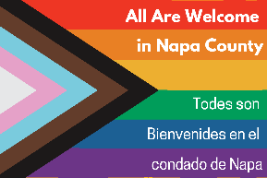

LGBTQ Action Item Agenda
January 10, 2022, 2-3 PM
https://countyofnapa.zoom.us/j/83115160131

- Introductions
- Last meeting recap
- Review/Approve Youth Outreach plan
- Finalize groups for outreach
- Finalize timeline
- Assign roles
- Review/Approve Staff survey
- Finalize individuals for outreach
- Design outreach plan
- Next steps

