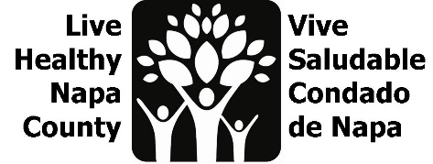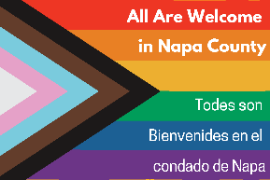

LGBTQ Safe Spaces Agenda
April 25, 2023, 2-3 PM
https://countyofnapa.zoom.us/j/82953427594
- Introductions
- Last meeting recap
- Review Youth listening session data
- Review staff survey results
- Design/redesign
  - Update safe space kits for Pride Month
  - Update “Roadmap to Inclusivity”
  - Begin to ideate youth project (timeline is below)
- Next steps

