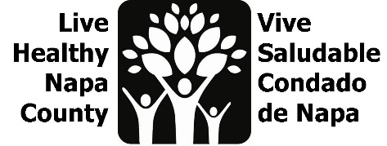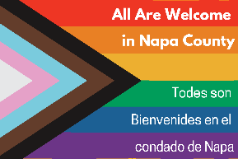

LGBTQ Safe Spaces Agenda
April 25, 2023, 2-3 PM

Por favor envíe un correo electrónico a LHNC@countyofnapa.org para recibir estas notas en español.
- Project Review
  - The goal of our project is to increase the amount and awareness of LGBTQ safe spaces in Napa County. We have wrapped our youth listening sessions and the staff survey will run through June. We are now focused on purchasing, gathering, and translating items for the 2nd prototype of our safe space kits.
- Review Youth listening session data
  - We engaged 26 youth, grades 6-12 in group listening sessions and 1x1 interviews
  - Please see the Powerpoint slides for themes from interviews/listening sessions
  - We will begin ideating out youth pojrect after our June dispersal of safe space kits.
  - We will use data from youth interviews to inform our edit of the “Roadmap to Inclusivity”.
- Design/Re-design of Safe Space kits
  - Our team reviewed the feedback from our first prototype (please see PowerPoint slides for detailed survey feedback) and will make the following changes/updates:
    - Pins, stickers, and window clings were used widely, and we have reordered these items for the new kits.
    - We will add more information that is staff/business facing: examples of inclusive hiring practices, diversity statements, land acknowledgments, icebreakers for staff, guidance around pronouns, etc. First Five has a student handbook we can pull from.
    - Update Roadmap to Inclusivity to included guidance about pronouns
    - We will work to make all kits bilingual
    - We won’t have books, so we will work to identify easy-to-read articles about allyship, gender inclusivity, and inclusive language. Brevity is important as we will need to translate.
    - First Five will fund a translator to review our Spanish for gender inclusive language. Thank you First Five!
    - HHSA had an ask for more kids activities in the kit. First Five and LHNC will work to translate First Five’s coloring sheets that feature BIPOC leaders and change makers.
    - Napa Valley printing aligns with our group values, we will check to make sure they are a vendor with the county.
    - We will create a Safe Space kit section on the LHNC website, and add all content, links to articles, and links to purchase new kit items. We’ll also include this info in the June LHNC newsletter
    - We’ll work with LGBTQ Connections to update training flyers where necessary.
    - We will contact commerce orgs to collaborate on kit dispersals.
- Next steps
    - Share Staff survey: https://www.surveymonkey.com/r/LGBTQsafespaces
    - Complete purchasing for safe space kits this week
    - Update Roadmap to Inclusivity using youth data
    - Begin to ideate for youth project (after June kit distribution)
    - Our next meeting date is Tuesday, May 23, at 2 pm. Meeting link is below and email invite will be send out shortly: https://countyofnapa.zoom.us/j/88456246776

