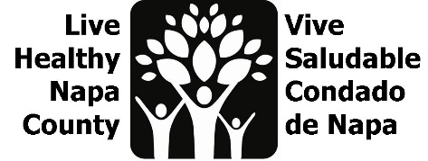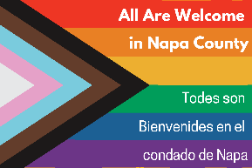

LGBTQ Safe Spaces Meeting Notes
May 23, 2023, 2-3 PM
Por favor envíe un correo electrónico a LHNC@countyofnapa.org para recibir estas notas en español.
- Project Review
  - Project goal: to increase the amount and awareness of LGBTQ safe spaces in Napa County. We have wrapped our youth listening sessions and the staff survey will run through June. At our last meeting, we discussed our focus on purchasing, gathering, and translating items for the 2nd prototype of our safe space kits. We will use data from youth interviews to inform our edit of the “Roadmap to Inclusivity”.
  - We engaged 26 youth, grades 6-12 in group listening sessions and 1x1 interviews. We will begin ideating out youth project after our June dispersal of safe space kits. We will continue to share the staff survey, linked in “next steps” section.

- Safe space kits update: Kits will updated over the next few months, using recipient feedback.
  - All materials will be bilingual
  - No book, swap for articles on allyship that we can translate
  - More staff facing materials including content for employee handbook recommendations, diversity statements, land acknowledgements, etc.
  - Coloring pages from First Five
  - All translated materials will be reviewed by First Five consultant for gender inclusive language.
  - This kit will be digital, with links to purchase physical items. This will allow us to update the content and provide links for recipients to purchase new items (stickers, flags, pronoun pins, etc.)
- Pride Month Activities
  - Because the business kits will be digital, we will use existing bag supplies for outreach at county Pride events. We will be in American Canyon and Yountville. Please contact Erin with other events we can distribute at, and/or if you want to table.
  - We will work with the Chamber of Commerce and Hispanic Chamber of Commerce to distribute any leftover kits, and/or do one day with the library.
  - LGBTQ Connections and First Five have partnered to create a pride month display for the DA’s office downtown. The 20 fit display will be designed to allow for it be continue to be featured in different location throughout the county. A draft image is below.
  - NCOE is doing a flag raising and “teach-in”, that could be a spot for safe space kit outreach, Bailie will make the connect.
- Next steps
  - Continue to share Staff survey
  - Assemble safe space kits
  - Update Roadmap to Inclusivity using youth data
  - Begin to ideate for youth project
  - Contact Erin with Pride month tabling opportunities or tabling availability
  - We will convene again in July to begin the ideation phase of our youth project. Proposed meeting date: July 11, at 2 pm

Pride Display for DA’s office: