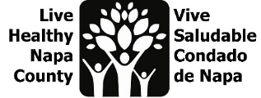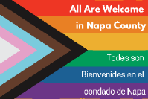
LGBTQ Safe Spaces Meeting Notes
July 11, 2023, 2-3 PM
Por favor envíe un correo electrónico a LHNC@countyofnapa.org para recibir estas notas en español.

- Project Review
  - Since this project began, we have dispersed 200 safe space kits!
  - In 2022, we conducted empathic interviews with business, education, and healthcare sectors “champions” to determine what safe spaces existed in the county, and what they had in common. We used that data to build our first prototype “safe space kits”. Based on feedback from that prototype, we are now creating digital bilingual safe space kits.
  - This year, we engaged 26 youth, grades 6-12, in group listening sessions and 1x1 interviews to determine how they defined safe spaces. We also surveyed 32 staff who work with youth.
- LGBTQ youth listening session and Staff Survey review
  - Please refer to the meeting slides for detailed quotes from both students and adults who work with youth.
  - After reviewing the data, meeting participants discussed potential “How Might We” questions that we will use to further define our youth project.
  - We are committed to re-engaging youth and adult participants once we have firm project idea to gather feedback and invite collaboration.
- Next steps
  - Please review the listening session and staff survey data and email any additional “How might We” questions to Erin.
  - We will continue our ideation phase, working towards a prototype in time for Fall, and continue working to create a bilingual digital safe space kits
  - Our next meeting will be on August 1, at 2 pm. Meeting invite will be sent out.

