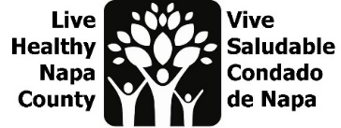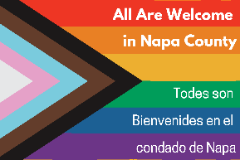
LGBTQ Safe Spaces Meeting Notes
August 1, 2023, 2-3 PM
Por favor envíe un correo electrónico a LHNC@countyofnapa.org para recibir estas notas en español.
- Project Review
  - Since this project began, we have dispersed 200 safe space kits! Kits were designed based on interviews with business, education, and healthcare sectors “champions” to determine what safe spaces existed in the county, and what they had in common. We are now designing our second prototype based on participant feedback, which will be digital and bilingual.
  - This year we engaged 26 youth, grades 6-12, in group listening sessions and 1x1 interviews to determine how they defined safe spaces. We also surveyed 32 staff who work with youth. We are now using that feedback to prototype a project for youth.

- Brief Data Review
  - Please refer to the July 11 meeting slides for detailed quotes from both students and adults who work with youth.
  - We briefly reviewed data and “How Might We” questions generated from 8/11 meeting and team member emails.
  - We selected three “How might we” questions to focus on.
    - How might recreate the feeling of wellness centers in every classroom?
    - How might we support parents who are struggling with their child’s identity?
    - How might we make clear the link between safe spaces and health equity?

- Prototype Design
  - After our ideation session (thanks for the great discussion team!) we choose three areas of focus, keeping mind project feasibility, current work already happening and team bandwidth.
    - Prototype a wellness corner in a classroom
    - Create a local LGBTQ data report
    - Develop a student advocate training program

- Next steps
  - Reach out to wellness center and wellness cafe to staff to understand their spaces and identify areas that can be replicated.
  - Identify a teacher or staff person who is willing to host our wellness corner prototype.
  - Begin to assemble data for local report.
  - Work with LGBTQ Connection and Friday Night Live to identify funding opportunities and potential programming for student advocate training.
  - Reach out to staff who provided their emails on the safe spaces survey and plan a meeting to share our data from youth listening sessions.
  - Continue design of digital, bilingual safe space kits.
  - Our next meeting will be on September 5 at 10 am. Meeting invite will be sent out.

