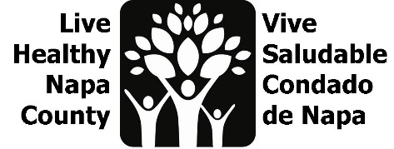
Mental Wellness Agenda
March 28, 2023, 2-3 PM
https://countyofnapa.zoom.us/j/82672427146

Por favor envíe un correo electrónico a LHNC@countyofnapa.org para recibir esta agenda en español.

- Introductions
- Project review
- Family Resource Center project
  - Feedback from Aldea and Kit makers
- Canvassing Plan
  - https://drive.google.com/drive/folders/1Iv-wSzcD35gtud6W2yi2D_-Y8AK7MSI2?usp=sharing
- Mental Health Month collaborations
  - Radio spots- PH and CAPC
- Next steps

