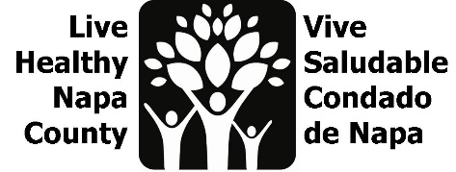
Mental Wellness Agenda
June 27, 2023, 2:30-3:30 PM
https://countyofnapa.zoom.us/j/85429678062

Por favor envíe un correo electrónico a LHNC@countyofnapa.org para recibir esta agenda en español.

- Introductions
- Project review
  - Mentis resource database
  - Mental Wellness Campaign- Resiliency: https://drive.google.com/drive/folders/1yni8Xi3b5PCkpOup8gqdRjdWzoBHPlJl?usp=sharing
  - Family Resource Center-Mental Wellness kits for Moms
  - Canvassing list: https://docs.google.com/spreadsheets/d/1zv0zX0FFhRVrfi4Y_hohqZOXdijjb8kx/edit?usp=sharing&ouid=100792811723716842739&rtpof=true&sd=true
  - Tracking Impact: https://docs.google.com/document/d/1F1oq5ZC0kE4prQwszSFL3byaFhE107lynlWCySz9Urk/edit?usp=sharing
  - CHAP engagement tool
- Next steps

