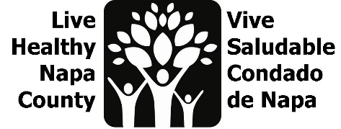
Mental Wellness Agenda
January 24, 2023, 2-3 PM

Por favor envíe un correo electrónico a LHNC@countyofnapa.org para recibir estas notas en español.

- Project review
We are working to amplify existing mental wellness campaigns and increase their reach to Spanish-Speaking Community members. We are currently focused on increasing warm-hand offs to Mentis’ Community Resource website, through flyers and mini presentations

- Flyer review/edits
The team reviewed two flyers, one bilingual and one in Spanish only. Comments are below. Please send any additional comments/edits to Erin.
- Header has been updated to Spanish. Lists of ages have been consolidated to create more space.
- We should use both flyers and place them in spaces according to language used.
- On the Spanish only flyer, we can change the blurb to say Spanish before English.
- We can include the website address for each page below the QR code.
- We can include logos from team partners. QVMC and Aldea have already sent theirs in.
- We can remove Mentis phone number and email from the flyer, folks can use the website to access that info.

- Presentation review/edits
The team reviewed the mini presentation slide deck. The goal is to use these at partner meetings if there is an ask for updates. Please send any additional comments/edits to Erin.
- Update language to Community Resources (remove youth)
- Update QR code and website address to go directly to community resource page

- Opportunities for collaboration
CAPC has monthly air time, we can ask to get on their schedule (perhaps for May?).
COVID vaccination program has a monthly bilingual segment, Ilse will see if we can get air time there.
QVMC is partnering with OLE Health in the emergency department. Terri will share this resource there and make sure flyers are distributed throughout their facilitites.

- Next steps
- Once flyer is finalized, we will move to print. We will send on last iteration via email, based on feedback from this meeting and subsequent meeting notes email. We will also send update powerpoint slides for feedback.
- HHSA-PH has presentations coming up for Parent University, we will add resource website slides to this presentation.
- We will update LHNC partners with the ask to share mentis slides whenever possible at next LHNC meeting (2/1, at 2 pm)
- We will measure our impact by tracking flyer locations, tabling opportunities, and slide presentations. Mentis can also track website engagement.
- We will create a shared google page to track impact
- Ilse will use flyer as a template to design social media images
- We will collaborate with LHNC partners to do a social media push in May (Mental Health Awareness Month)

