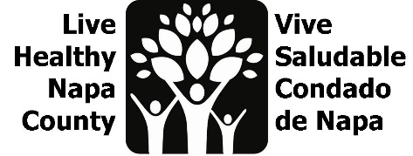
Mental Wellness Meeting Notes
February 28, 2023, 2-3 PM

Por favor envíe un correo electrónico a LHNC@countyofnapa.org para recibir estas notas en español.

- Project review
- We are working to amplify existing mental wellness campaigns and increase their reach to Spanish-Speaking Community members. We are currently focused on increasing warm-hand offs to Mentis’ Community Resource website, through flyers and mini presentations. We want flyers up for May, and will collaborate with partners for a social media push.

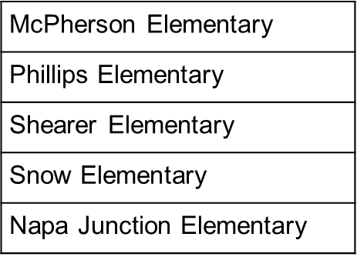
- Family Resource Center Feedback
- The education specialist team from Public Health presented at 5 Family Resource Centers in February. They presented a wide range of info including healthy eating, substance use (drugs, alcohol, vaping), vaccine and flue clinics, and our mini slide deck about the Mentis resource site.
- In total, 31 people attended these presentations, and they are looking forward to the team returning with more information and resources. Participants are all Spanish-speaking mothers with at least one child in elementary school. Some also have students in middle and/or high school.
- They are interested in more mental wellness information. They would like more info/resources about how to maintain their own mental health (participants describe bearing the brunt of labor at home and having no time for themselves) and are also seeking information about how to talk to their children about their mental health. They also expressed this subject is not often discussed in their culture, so guidance is welcomed.
- Aldea and Mentis have visited these sites as well, and Mentis visits monthly. We need to work with our partner orgs to make sure we are enhancing, and not duplicating the great work they are doing.
- May is Mental Health month and Mexican Mother’s Day is May 10. This is a great opportunity to cater some Mental Health support to this group of Moms. Maybe we can offer them a few ideas for support (prompts to talk to kids about mental wellness, self care tips, breathing medication, et.) and see what they are most interested in. The needs may be different at each site. Then, we could prototype some kits with information in Spanish, for Mother’s Day.
- Info packets can often have a lot of loose paper and brochures, how can we avoid that?
- A local group did a design project where they made mental wellness kits. We should engage them so we can learn from their experience. They might also have feedback from prototype users.

- Canvassing plan
- Flyers have been ordered! Erin will update team when they are available.
- The Language Inclusion plan presented data at the last LHNC meeting that we will use to determine where we post flyers. Please see meeting slide deck for details.
- We will work with the PH education specialist team and the Napa Suicide Prevention Council, as they will be visiting/posting flyers in similar areas. We want to help share their load when we can and post flyers for them, and they can help us post when applicable.
- The Language Inclusion team is working to identify trusted messengers as part of their design work. These are folks who work at the front desk at apartment buildings, staff at schools or the county, or even grocers. We will pull this data for our canvassing plan.

- Opportunities for collaboration
CAPC and PH have monthly radio slots. We need to create a short blurb for May that they can both share. PH has confirmed that we can have some airtime, we still need to reach out to CAPC. PH vaccination team would like to include a monthly mental wellness tip as part of their radio time. Can we help with that? Maybe work with HHSA-Mental Health, Mentis, or Aldea?

- Next steps
- Erin will reach out when flyers are ready.
- Create a location list for canvassing. Push out flyer in April, so they are up for May (Mental Health Month).
- Engage Mentis and Aldea to identify what info/resources they bring to FRCs.
- Engage mental wellness kit makers to learn from their experience
- Confirm radio spots and create bilingual content.
- Create a menu for FRC sites to choose content from, and prototype kits.
- Continue to measure impact on google doc.
- Next meeting is March 28 at 2 pm. Meeting invite will be sent out shortly.

