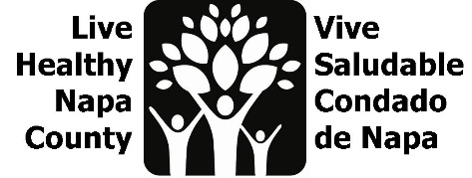
Mental Wellness Notes
April 18, 2023, 2-3 PM

Por favor envíe un correo electrónico a LHNC@countyofnapa.org para recibir estas notas en español.

- Project review
  - We are working to amplify existing mental wellness campaigns and increase their reach to Spanish-Speaking Community members. We are currently focused on increasing warm-hand offs to Mentis’ Community Resource website, through flyers and mini presentations. We want flyers up for May, and will collaborate with partners for a social media push.
  - In response to feedback from Family Resource Centers, we are working to create mental wellness kits, focused on Spanish-speaking mothers. We would like to have them ready for May, for Mental Health Month and Mother’s day.

- Family Resource Center project
  - We spoke with FRC leadership and they loved the idea of kits for moms. They serve 50-60 FRC parents through the Cafecito program (sponsored by Mentis) and they thought that would be a good venue for kit distribution.
  - Parent University staff presented our menu of possible kit items at the Cafecito on 4/18.
  - We will begin purchasing kit contents once we here that feedback.
  - Erin will communicate about kit progress over email in the coming weeks, rather than convene another meeting.

- Canvassing Plan
  - Canvassing has begun! We have created a list of locations based on the Language Inclusion team’s data, and Mentis has added to that list. We are collaborating with Mentis, the Public Health education specialist team, NOAA and Napa Suicide Prevention Council to collectively get all of our flyers up around the county. Please contact Erin if you would like some flyers.
  - We continue to track our impact via our share google doc. Please review and let Erin know if you would like to add a location: https://drive.google.com/drive/folders/1Iv-wSzcD35gtud6W2yi2D_-Y8AK7MSI2?usp=sharing

- Mental Health Month collaborations
  - A smaller group of mental wellness team members are meeting on 4/19 at 2 pm to share some campaign themes/ideas for May, with the goal of pushing out a collective mental wellness campaign. Please join if you are able: https://countyofnapa.zoom.us/j/84538892711
  - Based on the ideas generated, we will write our radio spots for May.

- Our next meeting will be in person, on May 9 at 2 pm, pending the arrival of all kit contents. This will be an in-person meeting to put the kits together. More info to come!

- Next steps
  - Begin purchasing for kits based on FRC feedback
  - Continue canvassing plan
  - Co-create messaging for May
  - Identify other areas for collaboration during May
  - Create radio spots in English and Spanish
  - Continue to measure impact on google doc
  - Next meeting date: Tuesday, May 9, at 2 pm, in person

