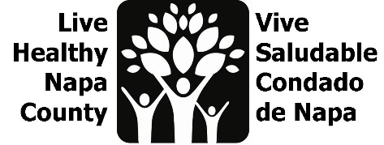
Mental Wellness Notes
June 27, 2023, 2:30-3:30 PM

Por favor envíe un correo electrónico a LHNC@countyofnapa.org para recibir estas notas en español.

Project review
Together, we have completed three large community projects. Materials and info from our projects can be found on the LHNC Mental Wellness Team G drive:

- Amplify the re-launch of Mentis’ bilingual resource database
We created Spanish and bilingual flyers, with QR code links to the website for distribution. We used data from the Language inclusion group to refine flyer distribution locations and partnered with Mentis staff to distribute flyers across the county. We created a mini slide presentation about the database and presented at various meetings, and at 5 Family Resource Centers. Our canvassing location list can be found here.

- Mental Wellness Kits
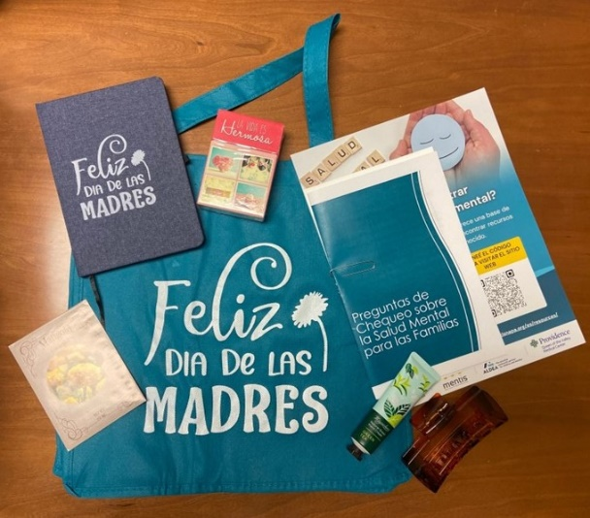
In response to feedback from Family Resource Centers, created mental wellness kits, focused on Spanish-speaking mothers. Each kit contained a booklet with check in questions for parents to ask their children, card for moms with ideas to support their own mental health, a journal, affirmation cards, a hair clip, lotion, marigold seeds, Mentis flyer, and suicide prevention information from HHSA Behavioral Health. Links to our kit materials can be found here. “The moms absolutely loved the wellness kits! They were super excited and happy when they received them. The especially loved the book with questions, the hair clips, and the journal.” -Maite, Parent University Site Coordinator

- Mental Health Awareness Month Campaign
We created Mental Wellness Campaign for May with a theme of Resiliency as a protective factor. Bilingual social media posts were pushed out each Monday, focusing on general resiliency, parental resiliency, youth resiliency, and community resiliency. The Public Health vaccine team let us use their May radio spots using the same messaging. Links to campaign materials can be found here.
- We measured impact for our projects on a shared chart here, please feel fee to add to it if you presented the mini slide show at any community meetings.

Next Steps
- As the next Community Health Assessment cycle is well underway, meeting participants decided to put a hold our activities for now. We anticipate Mental Wellness/Behavioral Health will emerge as a strong theme for our community. We look forward to creating a new Community Health Action Plan based on that emerging data. Our sincere gratitude goes out to this large team of partners who worked collectively to create and distribute bilingual mental wellness resources and messaging for our entire community.
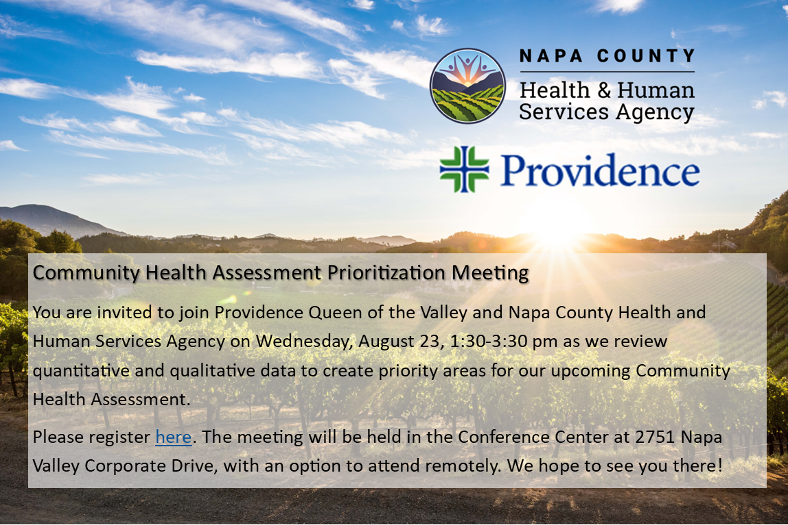
- You are invited to join Providence Queen of the Valley and Napa County Health and Human Services Agency on Wednesday, August 23, 1:30-3:30 pm as we review quantitative and qualitative data to create priority areas for our upcoming Community Health Assessment. We encourage partners to attend in person, and there will also be the option to join remotely. Registration is requested. we look forward to seeing you there!

