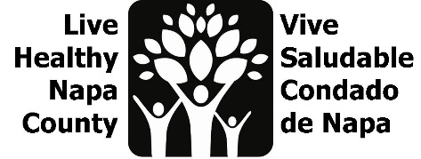
Youth Action Item Agenda
March 21, 2023, 2-3 pm
https://us02web.zoom.us/j/84813610668

- Introductions
- Project Overview
- Youth Leaders and Ethnography
    - LHNC has been working with a small group of youth leaders in American Canyon since November.
    - Youth leaders meet ~ twice a month to co-lead and develop a design project centered on youth social inclusion using Human Centered design principles
    - Youth have engaged their peers in ethnography to learn more about passions and how they connect with their community
      - Friends and family
      - Access to recreational and community spaces
      - Sense of comfort and community
      - Helping others with college
      - Connection to community organizations
      - Access to resources - ‘You’re not alone’
      - Community Service – food drive, library
      - Outdoor Spaces – Hiking
      - Holding spaces for youth to feel less isolated
      - Leveraging Action Team
    - Youth leaders are interested in outreaching to their peers and collecting more local information and opportunities to engage the local youth.
    - There are many community organizations that aim to engage you in some of these areas.
    - Napa RCD has field trips and internships for youth (Outdoor spaces)
    - Soroptimist Club is active in American Canyon and engages the community and youth. Has recently begun to engage the local middle schoolers
    - Outreaching to youth about community engagement activities is best done in person (warm hands-off); peer-to-peer
    - Feedback from LHNC youth leaders has been that they aren’t aware of programs or events that might interest them; they learn about them after the fact.
    - NVUSD uses Peach Jar and Parent Square to share community events and flyers for K-12; can be difficult to share on these platforms and these newsletters are often targeted at parents, not youth.
    - Best practices for outreach include physical flyers, social media, and connecting with school staff directly.
- Review Youth Activity Calendar
    - A potential project discussed previously to this group was the creation of a youth activity calendar where youth could design and upload local free youth activities and events
    - ParkRx has Outer Spatial app that can be used to post events that occur outdoors.
    - Support and coaching youth would be needed for this project. Social media accounts need to be maintained and have consistent engagement, otherwise, they don’t thrive.
    - Team discussed pivoting from this idea; look to utilize existing resources and platforms to increase youth engagement.
- Next steps
    - Identify and leverage opportunities for youth outreach
    - Continue convening and co-leading projects with Youth leads
    - Next Meeting: after May 3 partner meeting. Lesli will send a doodle poll.

